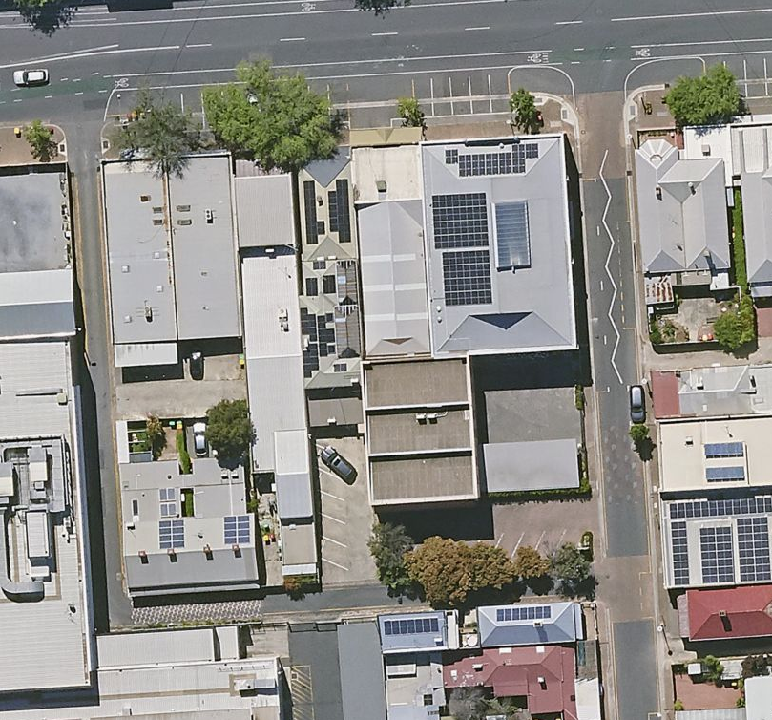
O’Brien Street
Sturt Street
One-way only in front of cottages to the driveway at the rear.
Two-way entry/exit from Sturt Street and O’Brien Street still possible as indicated.
ONE-WAY
NO ENTRY

