Facility | Key Details | How well does this facility align with the objectives and the principles of the draft Policy?
Box Factory  Community Centre  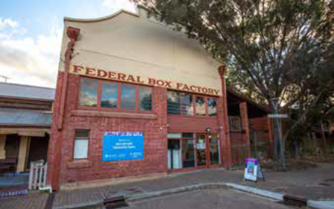 | Location:  Regent Street South  Building owned by: Housing SA  Unstaffed facility  Floor area: 360 sqm | This facility has limited accessibility during the day as it is subleased by the University of the Third Age from Monday to Friday from 9am until 4pm. The facility has limited visibility from the street. It has six meeting rooms and capacity for 240 people. It has the highest usage of the three community centres due to the size of the facility and the meeting room options.  Low alignment with Policy
North Adelaide  Community Centre/Library  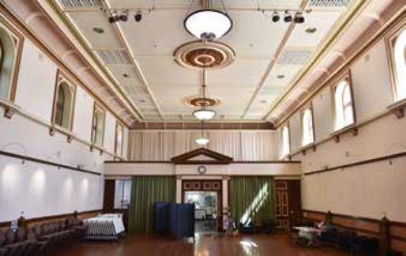 | Location:  Tynte Street  Building owned by City of Adelaide.  Staffed facility.  Floor area: 340 sqm | Large hall for hire, co-located with the library and community garden. Staffed facility with smaller meeting spaces for hire. Limited disability access and heritage controls which reduce flexibility.  Medium alignment with Policy
Minor Works Building  Community Centre  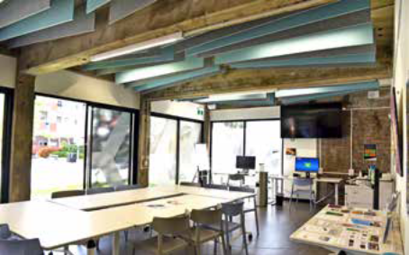 | Location:  Stamford Court  Building owned by: City of Adelaide  Staffed facility  Floor area: 357 sqm | Recent adaptive reuse with modern facilities, two rooms with total capacity for 90 people, building is disability accessible and has good indoor/outdoor connections. The centre is not located on a Main Street, has limited wayfinding signage, and is not close to public transport.  Medium alignment with Policy.

Facility | Key Details | How well does this facility align with the objectives and the principles of the draft Policy?
Hutt Street Library  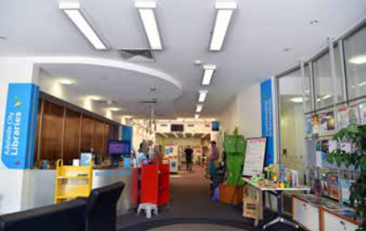 | Location:  Hutt Street  Leased from a private owner  Staffed facility  Floor area: 180 sqm | Located on a Main Street, approximately 50 metres to closest bus stop, good accessibility and ground floor visibility, well laid out floorplan based on room configurations. Small floor area, limited flexibility within room configurations. No capacity for co-location.  Medium alignment with Policy.
City Library  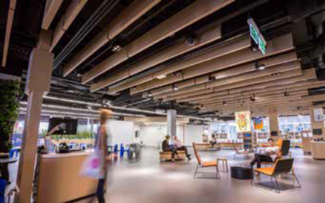 | Location:  Rundle Place, Francis Street  Leased from a private owner  Staffed facility  Floor area:  1,930 sqm | Located adjacent Rundle Mall with good public transport links, central location provides equitable access for City and metropolitan Adelaide visitors. Large flexible floor space with modern technology. Limited visibility from Rundle Mall and Grenfell Street, access via lift and stairs, no active ground floor.  Medium alignment with Policy.
Public Toilets  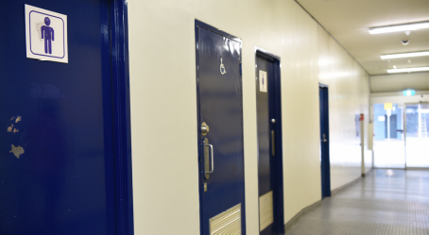 | 38 toilets owned and operated by the City of Adelaide including 21 Exeloos | The majority of the City, except for North Adelaide, around Adelaide Oval and the outer edges of the Adelaide Park Lands, is within 400-metre walking distance of a public toilet. Opportunity for upgrades as part of the Adelaide Park Lands Community Buildings (Sport and Recreation) Policy building upgrades. Limited facilities in Main Streets. Limited after-hours opening hours. Low satisfaction ratings from user surveys including safety and condition.  Medium alignment with Policy.

Facility | Key Details | How well does this facility align with the objectives and the principles of the draft Policy?
Playspaces  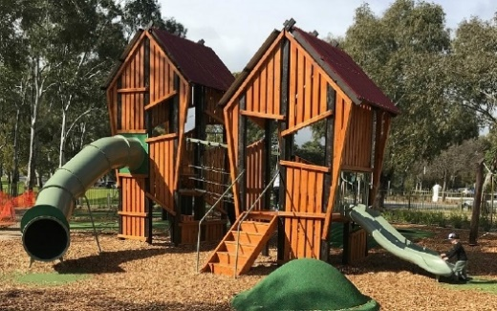 | 11 playspaces  Owned by City of Adelaide | The Adelaide Park Lands contain a mixture of play spaces predominantly servicing very young children, with some co-located with other recreation elements to enable intergenerational play (e.g. activity hubs in Park Bundey’s Paddock / Tidlangga (Park 9), Pelzer Park / Pityarilla (Park 19) and Mary Lee Park / Tulya Wardli (Park 27B). Greater connection with other recreation and sport facilities is worth consideration.  Play spaces that have been upgraded in the last 10 years (or so) generally incorporate imaginative play and inclusive features, with a stronger focus on landscaping and connections with their parklands setting.  There is an absence of children’s play opportunities within the City itself, with the Squares ideally located to service an emerging residential population of diverse household compositions and achieve the desirable service standard of quality open space within 400m of households.

Facility | Key Details | How well does this facility align with the objectives and the principles of the draft Policy?
Skate and BMX  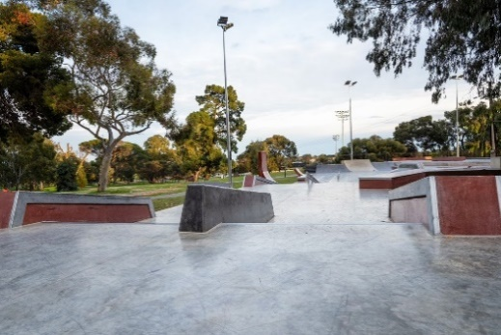 | One destination skate park and two satellite skate facilities  One BMX (City Dirt) facility containing four tracks/zones.  Owned by City of Adelaide. | The destination skate facility in Gladys Elphick Park / Narnungga (Park 25) is world class, with large carrying capacity.  The skate facility in King Rodney Park / Ityamai-itpina (Park 15) is in poor condition. With demand high and supply low in the eastern metropolitan region, the renewal/upgrade of this facility should be prioritised.  The BMX (City Dirt) facility in Blue Gum Park / Kurangga (Park 20) is a unique and popular offering, that would benefit from some investment to improve access and the overall experience.
Community Courts | Eight community sports courts and six 3-on-3 community basketball courts | Community courts in the Adelaide Park Lands that are accessible, incorporate lighting, and have nearby amenities are popular (e.g. Mary Lee Park / Tulya Wardli (Park 27B) and Pelzer Park / Pityarilla (Park 19)). The four community courts in Veale Park / Walyu Yarta (Park 21), lack these elements.
Dog Parks | Two dog parks | Both dog parks, geographically located in the north and south Adelaide Park Lands, are modern regional facilities containing appropriate amenities and features.

